Adult Patient Information
First Name: Middle: Last: Today’s Date:

Called name: Marital Status: M S D W Date of Birth:
SSN#: Gender: M F
Address: City: State: Zip:
Contact Number: Email:
Employer: Work Number:
Emergency Contact: Relationship: Phone Number:
How did you hear about us?
Referred by:
Has a Physician treated you for any health conditions in the last year? If yes, please explain:

Please note any significant family medical history:
List the approximate dates of any operations, falls, injuries, unusual diseases, serious illnesses, or accidents (including broken bones, including this year:

List any known allergies:
Please list any drugs/medications, vitamins, herbs/other you are taking and why: (additional room on back)

Toxins
Current, everyday smoker: Y/N How many packs per day?
Former Smoker: Y/N When did you start? Quit?
Never Smoked: Y/N
Do you currently drink alcohol? Frequency? Quit?
Do you use or have you used recreational drugs? When did you start? Quit?

Current Health Conditions
Chief complaint/problem(s):

How and when did symptoms first occur:

Have you ever received care for this condition before Y/N If yes, please explain:

List any doctors seen for these problems:

List diagnosis(es) and type of treatment(s)

Does this interfere with your daily and/or work activities? Y/N
If yes, please explain:

Have you had similar symptoms or injuries before? Y/N
If yes, please explain:

Exercise Frequency? What type of exercise?
How do you normally sleep? Back/Side/Stomach Do you wake up: Refreshed/Ready or Stiff/Tired
List any issues with flexibility (ex-putting on pants, shoes, or range of motion)
Do you commute to work? If yes, how many minutes per day?
How many hours per day do you spend sitting at a desk?
How many hours per day do you spend on the tablet, computer, or phone?
List the conditions that you are most interested in getting corrected, in order of importance:

Chiropractic History
Have you ever visited a chiropractor? Y/N If yes, what is their name?
What would you like to gain from chiropractic care?
Resolve existing conditions Overall Wellness Both

Acknowledgement and Consent
Patient Signature: Date:

Welcome to Our Clinic
We assure you we will do everything we can to correct your spinal problem in the shortest amount of time, so it is most cost effective for you. You will find our atmosphere is not “stiff collar professional” but more “down home” because we treat our patients like family members. Please understand payment of your bill is considered a part of your treatment. The following is our Financial Policy that we require you read and sign prior to any treatment.
Full payment is due at the time of service unless other arrangements are made!
**We accept cash, check, Care Credit, Mastercard/Visa, Discover and American Express**
We may accept assignment of insurance benefits after your insurance has been verified, and your deductible has been met. However, we require the co-payment/allowable amount portion of the bill to be paid at the time of service. The balance is your responsibility whether your insurance company pays or not. We cannot bill your insurance unless you bring all current insurance information. Your insurance policy is a contract between you and your insurance company. We are not a party to that contract. In the event we do accept assignment of benefits, we will file your insurance for you. If your insurance company does not pay within 45 days, your balance will automatically become due and payable to you. If your company denies any amounts billed by this office, we will provide you with any assistance necessary, but you will be required to contact your company and negotiate with them. Please be aware some and perhaps all the services provided may be non-covered services, or not be considered reasonable and customary depending on your insurance company.

Our practice is committed to providing the best treatment for our patients, and we charge what is usual and customary for our area. You are responsible for payment regardless of any insurance company’s arbitrary determination of usual and customary.

The adult accompanying a minor and the parents (or guardians) are responsible for full payment. For unaccompanied minors, non-emergency treatment will be denied unless prior arrangements have been made for payment, or payment accompanies the minor.

Authorization and Assignment
Greenacres Chiropractic Clinic is authorized to release any information they deem appropriate concerning my physical condition to any insurance company, attorney, or adjustor to process any claim for reimbursement of charges incurred at Greenacres Chiropractic Clinic by me.

I authorize the direct payment to you and of any sum I now or hereafter owe by my attorney out of the proceeds of any settlement of my case, and by any insurance company obligated to reimburse me for the charges for your services or otherwise obligated to make payment to me or you based in whole or in part upon the charges make for your services.

I authorize Greenacres Chiropractic Clinic to contact my insurance company to attempt to reconcile any problems that may arise if my claims are not paid in a prompt manner. If there is need for any cause of action, I will be responsible for instituting such action. I understand that I am responsible for all charges incurred in this office, regardless of what my insurance company pays.

I have read and understand all the above and agree:
Patient’s Printed Name:

Patient Signature: Date:

Acknowledge for Consent to Use and Disclosure of Protected Health Information

Use and Disclosure of your Protected Health Information
Your Protected Health Information will be used by Greenacres Chiropractic Clinic or may be disclosed to others for the purposes of treatment, obtaining payment, or supporting the day-to-day healthcare operations of this office.

Notice of Privacy Practices
You should review the Notice of Privacy Practices for a more complete description of how your Protected Health Information may be used or disclosed. It describes your rights as they concern the limited use of health information, including your demographic information, collected from you, and created or received by this office. I have received a copy of the Notice of Privacy Protection Policy ______ (Patient Initials)

Requesting a Restriction on the Use or Disclosure of Your Information
- You may request a restriction on the use or disclosure of your Protected Health Information.
- This office may or may not agree to restrict the use or disclosure of your Protected Health Information.
- If we agree to your request, the restriction will be binding with the office. Use or disclosure of protected information in violation of an agreed upon restriction will be a violation of the federal privacy standards.
Notice of Treatment in Open or Common Areas
Some treatment may be performed in an “open” area. Private areas are available to discuss your health information upon request.

Revocation of Consent
You may revoke this consent to the use and disclosure of your Protected Health Information. You must revoke this consent in writing. Any use or disclosure that has already occurred prior to the date on which your revocation of consent is received will not be affected.

By my signature below I give my permission to use and disclose my health information.

Printed Name (please use full name):

Patient Signature: Date:

Consent for Chiropractic Treatment & Acknowledgement of Receipt of Information
Every type of health care is associated with some risk of a potential problem. Health care providers, including chiropractors, are required, by law, to tell you the nature of your condition, the general nature of the treatment, the risks involved, and the reasonable therapeutic alternatives.

In keeping with the Louisiana law of informed consent, you are being asked to sign a confirmation that we have discussed all these matters. We have already discussed with you the common problems and risks. Please read this form carefully. Ask about anything you do not understand, and we will be pleased to explain.

In general, chiropractic treatment includes examination, taking of x-rays, manipulation/adjustment, and application of physical therapy modalities. Although their occurrence is extremely remote, some risks are known to be associated with these procedures. These include:
- Stroke: Stroke is the most serious problem associated with spinal manipulation. The results can be temporary or permanent dysfunction of the brain, with a very rare complication of death (1 in 20 million). Spinal manipulations have been associated with strokes that arise from the vertebral artery (located in the neck vertebrae). (This problem occurs so rarely that there is no conclusion data to quantify probability.)
- Disc Herniations: Disc herniations that create pressure on the spinal nerve or spinal cord are frequently successfully treated by chiropractors. Rarely, treatment may aggravate the problem, resulting in an increase in low back pain, radicular pain, and numbness of a transient nature. Residuals may last for a few days but seldom for longer periods of time.
- Soft Tissue Injury: Soft tissue primarily refers to muscles and ligaments. Muscles move bones, and ligaments limit pain with necessary treatments for resolution, but there are no long-term effects for the patient.
- Rib Fractures: The ribs are found only in the thoracic spine or middle back. Rarely, a manipulation will fracture a rib bone. This occurs only in patients who have weakened bones from such things as osteoporosis. Osteoporosis can be noted on your x-rays. We adjust all patients carefully, especially those who have indications of osteoporosis on their x-rays.
Consent
I hereby authorize and direct Steven Kyle Wunnenberg, D.C., DBA Greenacres Chiropractic Clinic, together with associates and assistants of his/her choice, to provide chiropractic treatment including examination/diagnostics, spinal manipulation/adjustment, various modes of physical therapy, x-rays and any additional procedures of service that may be deemed necessary or reasonable. This treatment has been explained to me, and alternative methods of treatment (if any) have also been addressed. I have read and understand all information set forth in this document, including any attachments. I acknowledge that I have had the opportunity to ask any questions about the contemplated procedure and that my questions have been answered to my satisfaction. This authorization for and consent to chiropractic treatment is and shall remain valid until revoked.

Printed Name:
Patient Signature: Date: Time:
I certify that I have provided and explained the information set forth herein, including any attachments, and have answered all questions concerning proposed treatment to the best of my knowledge and ability.
Physician’s Signature: Date: Time:

Cancellation Policy

Please respect your appointment time; if you must cancel, 24 hours is required.

If you or your child are unable to make your appointment, please let us know at least 24 hours in advance. Our clinic maintains a waiting list of patients who would like to be worked into our schedules and we can give them the care they need if we are aware of an open appointment time.

Appointments that are missed with no notice or those canceled with less than 24 hours’ notice will be billed at the rate of $20.00 which is not billable to insurance.

Please note that if you are more than 15 minutes late, your appointment will be considered a cancellation and you will likely not be able to receive treatment until your next scheduled appointment.

We understand illnesses, accidents, and events that can prevent you from keeping your appointment and we will extend a one-time exception for a missed appointment without notification.

My signature below is my acknowledgement that I have read and understand the Cancellation Policy.

Printed Name:

Patient Signature: Date:

Treatment and Progress Notes

Patients Name: Date:

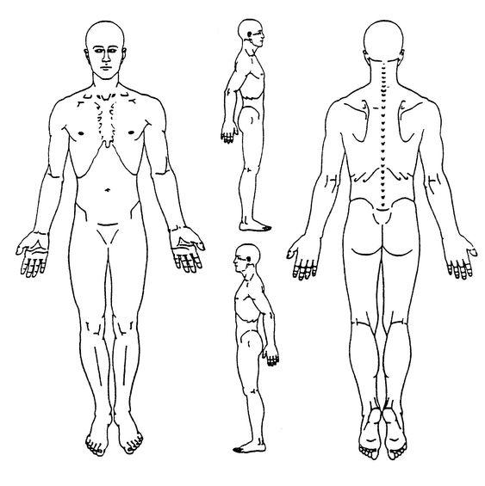
Please indicate the area of your symptoms

